The Restless Temple
JUNE 2014

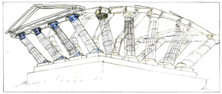

The story started in 1999 when I was invited to a ‘Pre Millennium Tension’ weekend at Dartington College and, inspired by a reaction to the more jingoistic plans to celebrate 2000, I thought of commemorating the discovery of splitting the atom. I thought of the second atomic bomb tested in the USA in 1953, and an extraordinary film made of a frame building being blown apart in the force field of the explosion.

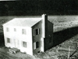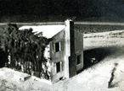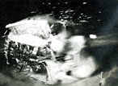

Then I thought of a glass temple blowing in the wind. This is the first model I made

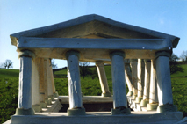

In 3/2002 I rang Ove Arup to find out if they would be interested in working out how this structure could work. I talked to Pat Dallard the day they solved the wobble on the Millennium Bridge. He invited me up to talk to them and I made the second temple model. The idea excited them enough to donate the time and expertise of Jackie Lo, one of their top Structural Engineers, to work with me to develop the engineering. This generous contribution of expertise continued across about one and a half years.

6/2002 I started to write to people who might be interested. Hugh Mellor, The National Trust’s Historic Buildings Representative asked the reps from the Cornwall/Devon what they felt about the temple on National Trust land. They felt it might be hard to get planning permission. He suggested trying Clive Adams of the Poltimore Trust. Everyone I talked to was certain it must be built. Maggie Bolt, Public Art South West, sent me off to see many people for advice and support.

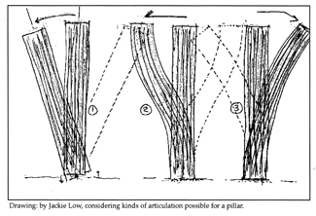
7/2002 Preliminary drawings and timetable from Ove Arup arrived with a price list, which made going into the next stage a problem. I had to find a positive response regarding a site.

9/2002 Hoping to interest a person who owned a great deal of Cornwall I wrote to Ben Bolger of The Prince’s Foundation. He felt it was not the sort of project they would support but added wonderful suggestions about Fijian Buras and other contacts to try.

I went to see Adrian Vinken of Plymouth Theatre Royal who was also chairman of Culture South West. He has been a true champion throughout and would very much like to see the temple built.

11/2002 At this time I was awarded a Gulbenkian Foundation Science Art Grant of £5,000 for research. I went on looking for ways to raise the funding to build the temple. There was still not enough for the next stage of Arup’s researches to go ahead.

1/2003 Adrian Vinken spoke to Mark Harold of The National Trust who was enthusiastic but felt we needed further feasibilty input from Ove Arup.

All this time I was working full-time with Forkbeard Fantasy, the multi-media theatre company. Since 1979 I have co-written all their touring theatre shows, designed and built all the animated sets and automata, and designed their numerous films and exhibitions. Forkbeard have toured across the world and all over the UK, from the smallest village hall in the Hebrides to the main stage of the Royal Shakespeare Theatre. The Forkbeard workload has always been considerable and as a result my ability to focus on the Temple has always been fractured and intermittent.

4/2003 I met up with Adrian Andrews, a designer who had researched the mathematics and sacred symbolism involved in the design of temples and their proportions.
I spent my spare time investigating Cornwall, looking for suitable sites – good hills, sea winds, potential for temporary planning permission. Upton Towans near Hayle, or behind St Austell in the clay workings excited me especially. I would love the Temple to go to these places one day.

12/2003 Ove Arup dedicated Charles Walker and Martin Self to the temple, all still free. Charles worked in the Advanced Geometry Unit and by February 2004 he had produced a draft proposal for the temple. A problem emerged. The suggestions seemed to involve too heavily built structures. I didn’t know how to express why or how I thought I had the ‘right’ to question their design. I retreated in confusion.

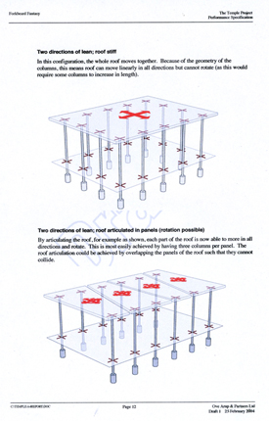

5/2004 Sian Ede of the Gulbenkian Foundation, introduced me to Dr Mark Miodownik of Kings College London, a materials expert and lecturer in Mechanical Engineering. He helped me with my confusion and suggested it was possible I understood more about engineering than I thought, but did not know the language and terms to use. He believed I should be working with Mechanical Engineers because of the dynamic nature of the temple. He suggested I should apply for a Nesta Award to learn the language of the engineer.

I looked for people in the massive heavy world of Mechanical Engineering to compile a ‘group of teachers’ that I could then take time off to work with on a Nesta Award.

8/2004 I went to see Jamie Taylor a wonderful spirit of The Wave Power Group at Edinburgh University. As they are studying collecting energy from the waves, their lab was a fantastic workshop that could make water do almost anything. Jamie was very inspirational and dynamic. He suggested elastomeric hinges as the link between the activity of the columns and the supporting base.

I imagined hinges that could work like the Coco de Mer palms I’d seen in the Seychelles which have an incredible way of moving in typhoons by rolling in their bases like a loose egg in an eggcup.

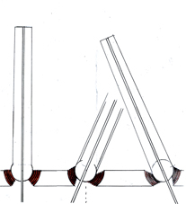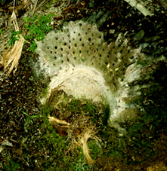

I went to see Professor Adam Crewe at Bristol University, a specialist in the engineering used to protect structures from earthquakes. He was the first engineer I had heard imagine the temple working. We discussed my experimenting with the temple structure with his technicians.

Adam and I worked out the timetable and cost for a Nesta application. Through Adam’s support and enthusiasm I collaborated with two of his students who were ‘given’ The Temple for final PhD Engineering paper.

9/2004 At this time, wanting to know more about engineering I signed up for a NVQ course in Workshop Engineering at Somerset College. For one day a week a small group of rather gloomy young men and I learnt to use lathes; they were much better than me.

9/2004 I arranged with Ian Duncan of Structures 1 in Bristol to have a series of seminars about the language of Engineering, the terms that describe the physical laws of structure, standing still, or falling down. He taught Structural Engineering at Bristol University and felt his students needed a deeper comprehension of this language.

12/2004 I applied to Nesta. I was short listed, but at the final interview failed. I could not do the blah about myself. I learnt that I find it difficult to see myself as special, but I can easily see the Temple as special. The experience made me realize I have to be careful about how to achieve the last stage of making the Temple a reality, the public emergence, the high profile necessary to make such a big project happen. It made me consider new ways in which the Temple could be created.

12/2004 At Sian Ede’s suggestion I contacted Jem Finer of The Pogues and an artist fascinated by unusual structures, and Sue Hill and Bill Mitchell of Kneehigh Theatre for their intimate knowledge of Cornwall. Had a long emailing with Jem about his astral investigations, and letters of very warm support from Bill.

5/2005 first contact with Jude Kelly and the idea of suggesting the temple for the Cultural Olympiad.

8/2005-6 Lani Tan and Hannah Steer at Bristol University produced their PhD
about the temple, “The Kinetic Temple, Engineering meets Art” and were awarded a 2.1. The previous year I had also worked with Jen Horrocks a student at Kings College under the supervision of Mark Miodownik.

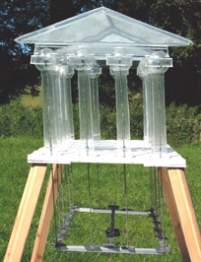

For Lani and Hannah I built a model to work with right from the beginning. This enabled us to test the model in the University’s wind tunnel. I built this model using pendulums to make the structure move easily. I made the model so the length and weight of the pendulums could be changed. I supplied a choice of connections for the columns at the top. As they experimented, friction was a problem so the pediment connections at the top disappeared completely leaving each column with its own bit of pediment. We discovered that it was how the pendulums were joined at the bottom that should control the behaviour of the columns, preventing them from hitting each other.
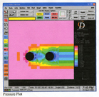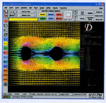

These diagrams from their thesis showed the effect of turbulence.

2008 For the next two years I am distracted by two major Forkbeard theatre shows, a touring exhibition and several FF Summer Schools and courses.

Adam’s Compound 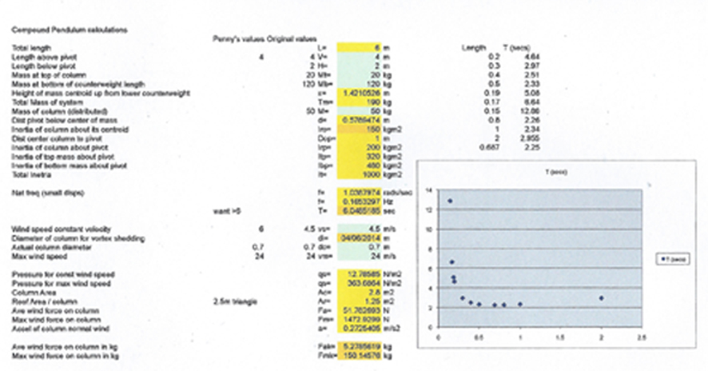Pendulum Calculations suggest the column at 4m high should not exceed 16K in weight.

2/2008 Adam Crewe is someone I have always found very inspiring. Following on from where Lani and Hannah’s work had finished, we decided a half sized column with its pendulum had to be built to test one column’s behaviour in reaction to different wind strengths and directions. The graph of the ‘Compound Pendulum Calculations’ suggested that the column and its pendulum would become very unpredictable if the column was heavier than 30 kilos. This calculation was based on the column being 4m high. For strength with lightness there seemed little choice in materials other than fiberglass resin. So I made a half sized column weighing just over 15K, and tested its reaction to winds, which I also filmed.

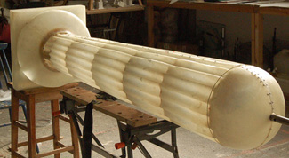

4/2008 Pat Dallard (Arup) is still interested, likes the idea of pendulums and using compressed air.

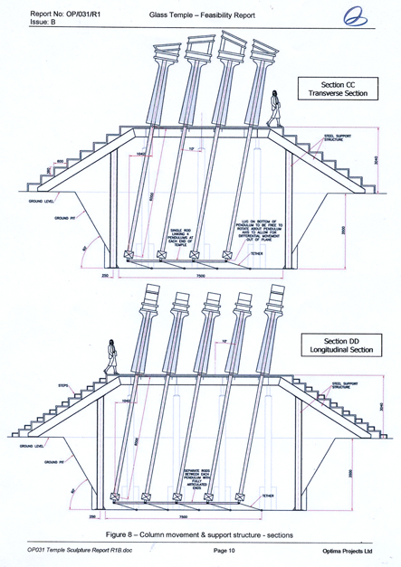

6/2008 I now felt it was time to commission a feasibility report that would investigate the ideas discovered so far and produce more conventional evidence that the Temple would work. Asked David Kendall of Optima Projects to do this. He is a specialist in advanced engineering design and composite materials.

5/2009 I bid for the 2012 Olympics Artists taking the Lead to create a sculpture for the South West but the application does not succeed.

10/2009 Steve and Loretta MacNicholas who created the show STOMP are interested in supporting/becoming involved with the temple.

2010 I realized a full-scale experimental temple had to be built to test how easily and ‘watchably’ it moved. While working in the wind tunnel and with hair driers on the small model it was clear how important the scale and variety of wild wind is. The model had to be close to the scale of the real wind. We had to find out how heavy the temple could be to work well with the counterweights – and how far should the pendulums be from the pillars. Where could I get the gimbals?

And then I was introduced to Rob Higgs a sculptor who not only understands mechanical engineering but makes extraordinary mechanisms and working sculptures himself.

At the beginning of 2010 he agreed to help build a test structure, which he has achieved in between many other jobs. He designed and fabricated the engineering while I made the 14 cedar temple pillars. We erected the full size Temple and watched how it responded to the winds, adjusting the weights on the pendulums. It withstood last winter’s weeks of gales and we knew it would work at last.
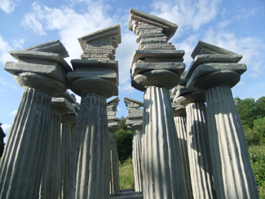

During this time I had a number of meetings with Neil Armstrong at Tremenheere Sculpture Gardens outside Penzance. He said he would love to host the Temple there. We looked at various possible places in the gardens but came up with the proposed site because of its unique public access, on a spectacular hill above their entrance and visitor centre, just yards from The Pilgrims Way, and looking directly out across to St Michael’s Mount.

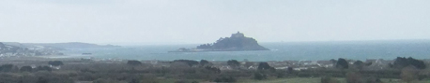

And in the last few months Peter Hampel, co-founder of The Lost Gardens of Heligan and The Eden Project, has taken on the role of Producer on the Temple and together we are now all working towards opening The Restless Temple to the public at Tremenheere in April 2015 where it will remain for two years before touring to other special sites across the UK and Europe.

